SEGMENT TREE
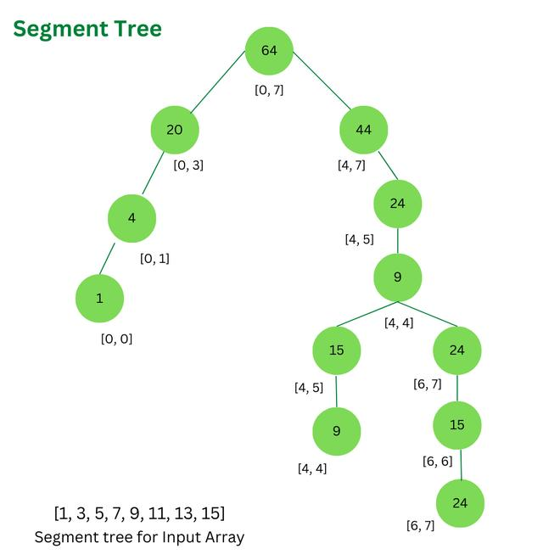
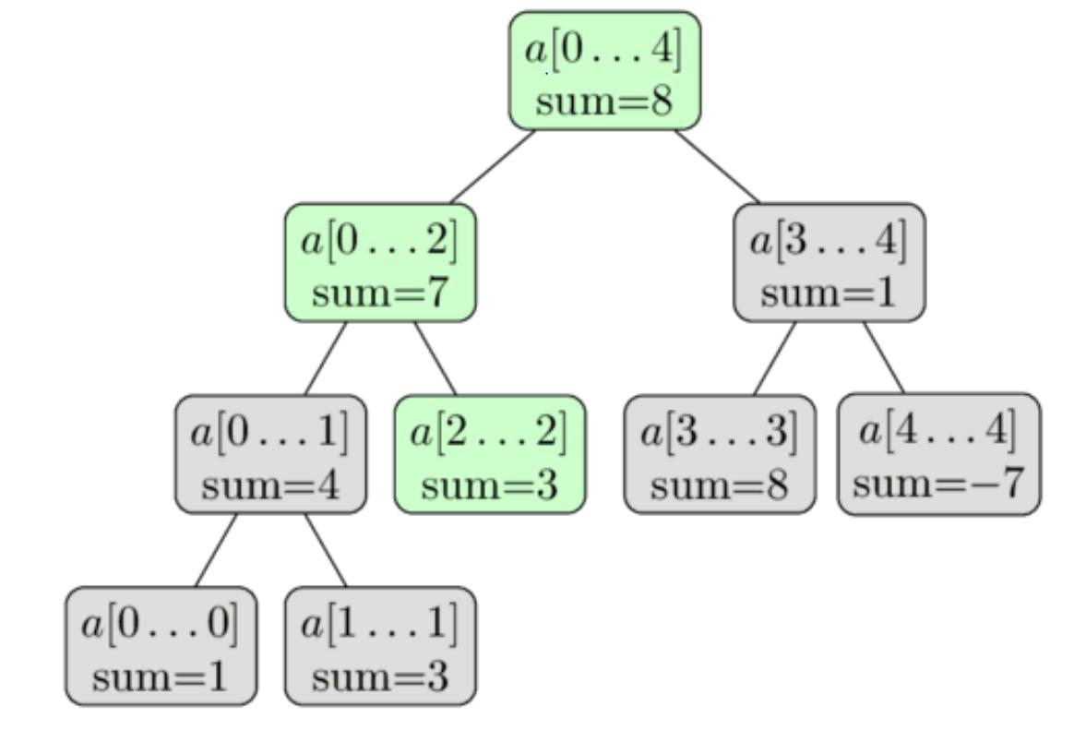
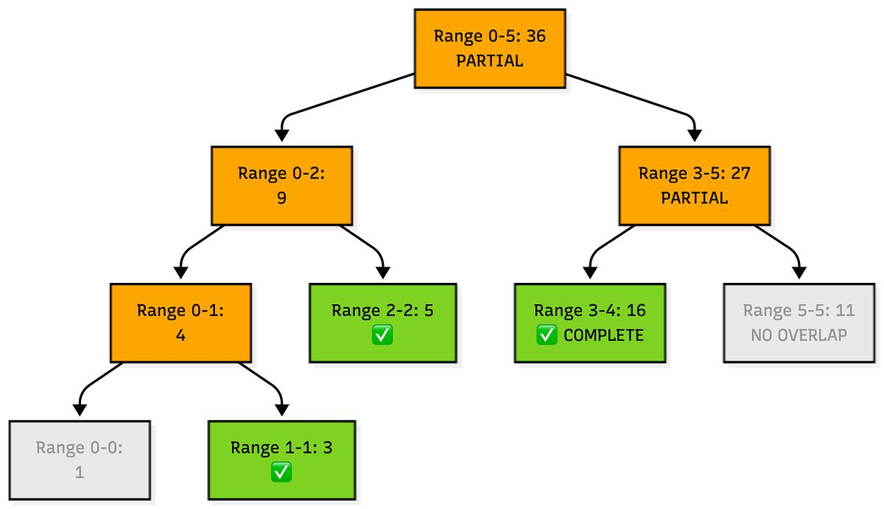
4

🔷 1. INTRODUCTION
✅ Definition
A Segment Tree is a tree-based data structure used to efficiently perform:
- Range queries (sum, min, max, etc.)
- Updates (modify elements)
👉 It divides an array into segments (subarrays) and stores results in a tree.

📘 Why Segment Tree?
Without Segment Tree:
- Query (sum/min) → O(n)
- Update → O(1)
With Segment Tree:
- Query → O(log n)
- Update → O(log n)
👉 Huge improvement for multiple queries

🔷 2. STRUCTURE OF SEGMENT TREE
Example Array:
[1, 4, 5, 9, 10, 12]
Tree Representation:
- Root → sum(0–5)
- Left → sum(0–2)
- Right → sum(3–5)
Then further divided until:
- Leaf nodes → single elements
👉 Total nodes ≈ 4n

🔷 3. BUILDING SEGMENT TREE
⚙️ Working
Divide array recursively
📌 Steps
- If start == end → leaf node
- Else:
  - Find mid
  - Build left subtree
  - Build right subtree
  - Combine (sum/min/max)

🧾 Example (Sum Tree)
Node(0–5) = 1+4+5+9+10+12 = 41
Node(0–2) = 10
Node(3–5) = 31

⏱ Complexity
- Build → O(n)

🔷 4. RANGE QUERY (l, r)

⚙️ Idea
Compare query range with node range

📌 3 CASES
✔ Case 1: Complete Overlap
Node fully inside query
👉 Return value

❌ Case 2: No Overlap
Node outside query
👉 Return neutral value (0 for sum)

🔄 Case 3: Partial Overlap
👉 Split into left + right
👉 Combine results

🧾 Example
Query sum(1,4)
👉 Split into segments:
- sum(1–2)
- sum(3–4)

⏱ Complexity
- Query → O(log n)

🔷 5. UPDATE OPERATION

⚙️ Idea
Update element and propagate upward

📌 Steps
- Go to leaf node
- Update value
- Update all parent nodes

⏱ Complexity
- Update → O(log n)

🔷 6. LAZY PROPAGATION (VERY IMPORTANT)

⚙️ Problem
Range updates are slow without optimization

💡 Solution
Delay updates using lazy array

📌 Steps
- Store pending updates
- Apply only when required
- Push updates to children

⏱ Complexity
- Range update → O(log n)

🔷 7. TYPES OF SEGMENT TREE
- Sum Segment Tree
- Min Segment Tree
- Max Segment Tree
- GCD Segment Tree

🔷 8. APPLICATIONS
- Range sum queries
- Range minimum queries
- Competitive programming
- Interval problems
- Lazy updates

🔷 9. ADVANTAGES
✔ Fast queries & updates
✔ Flexible (many operations)
✔ Works for dynamic data

🔷 10. DISADVANTAGES
❌ Uses more memory (≈ 4n)
❌ Complex implementation

🔷 11. SEGMENT TREE vs OTHERS
Feature | Segment Tree | BIT | SQRT
Query | O(log n) | O(log n) | O(√n)
Update | O(log n) | O(log n) | O(1)
Flexibility | High | Medium | Low

🔷 12. PSEUDOCODE (EXAM READY)

Build
build(node, start, end):
if start == end:
tree[node] = arr[start]
else:
mid = (start + end) / 2
build(left)
build(right)
tree[node] = left + right

Query
query(node, start, end, l, r):
if no overlap:
return 0
if complete overlap:
return tree[node]
return query(left) + query(right)

Update
update(node, start, end, idx, val):
if start == end:
tree[node] = val
else:
update(left/right)
tree[node] = left + right

🧠 FINAL MEMORY TRICK
👉 Segment Tree = Divide + Store + Query

🧾 FINAL 5-MARK ANSWER
- Segment Tree is used for efficient range queries
- Built by dividing array into segments
- Supports query and update in O(log n)
- Stores results in tree nodes
- Used in competitive programming

